## Unveiling Market Insights: Analysing Spending Behaviour and Identifying Opportunities for Growth

1. Introduction
   1. overview

Wholesaling or distributing is the sale of goods or merchandise to retailer to industrial, commercial, institutional or other professional businessman to other wholesalers (wholesale businesses) and related subordinated services. In general, it is the sale of goods in bulk to anyone, either a person or an organization, other than the end consumer of that merchandise. Wholesaling is buying goods in bulk quantity, usually directly from the manufacturer or source, at a discounted rate. The retailer then sells the goods to the end consumer at a higher price making a profit.

PURPOSE :

**Clarity**: The purpose statement should be unambiguous and easily understood by all stakeholders, including project team members, sponsors, and other relevant parties.

1. **Alignment with Goals**: It should be aligned with the strategic goals and objectives of the organization. The project's purpose should contribute to the broader mission or business objectives.
2. **Focus**: It helps maintain focus on the essential goals and prevents scope creep or mission drift. All project activities should be directed toward fulfilling this purpose.
3. **Decision-Making**: The purpose of the project guides decision-making throughout its lifecycle. It provides a reference point for evaluating options and trade-offs.
4. **Communications**: It serves as a communication tool to convey the project's intent to stakeholders, making it easier to gain their support and commitment.

PROBLEM statement & Design thinking :

1. **Specificity**: Business requirements should be specific and unambiguous. They should clearly outline what is expected and leave no room for interpretation.
2. **Measurability**: They should be measurable and quantifiable whenever possible, allowing for the establishment of success criteria and performance metrics.
3. **Relevance**: Business requirements must be directly aligned with the business goals and objectives. They should address a genuine need or problem within the organization.
4. **Clarity**: The language and format used in documenting business requirements should be clear and easily understandable by all stakeholders.
5. **Consistency**: Business requirements should be consistent with each other and with the broader business strategy. Inconsistencies can lead to confusion and conflicts.
6. **Traceability**: Requirements should be traceable, meaning they can be linked to specific business goals, user needs, or regulatory compliance.
7. **Prioritization**: Not all requirements are of equal importance. It's essential to prioritize them, distinguishing between "must-have" (critical) and "nice-to-have" (non-critical) requirements.
8. **Documentation**: Business requirements are typically documented in various forms, such as requirement documents, use cases, user stories, or process flow diagrams.
9. **Communications**: It serves as a communication tool to convey the project's intent to stakeholders, making it easier to gain their support and commitment.
10. **Evaluation**: The purpose statement enables the assessment of project success by providing a basis for measuring whether the project has fulfilled its intended objective.
11. **Motivation**: A clear project purpose can inspire and motivate the project team and other stakeholders, as it underscores the significance and value of the project's outcome.
12. **Accountability**: It establishes accountability by defining what is expected from the project and who is responsible for achieving the defined purpose.

Example of a Project Purpose Statement: "The purpose of this project is to develop and launch a new e-commerce website that will increase our online sales by 20% within the next 12 months, improving the accessibility and user experience for our customers while strengthening our digital presence in the market."

In summary, the purpose of the project is a foundational statement that provides a clear, concise, and strategic explanation of why a project is being undertaken. It helps ensure that the project is aligned with the organization's objectives and provides a common understanding of the project's goals among all stakeholders.

Top of Form

EMPATHY :

Z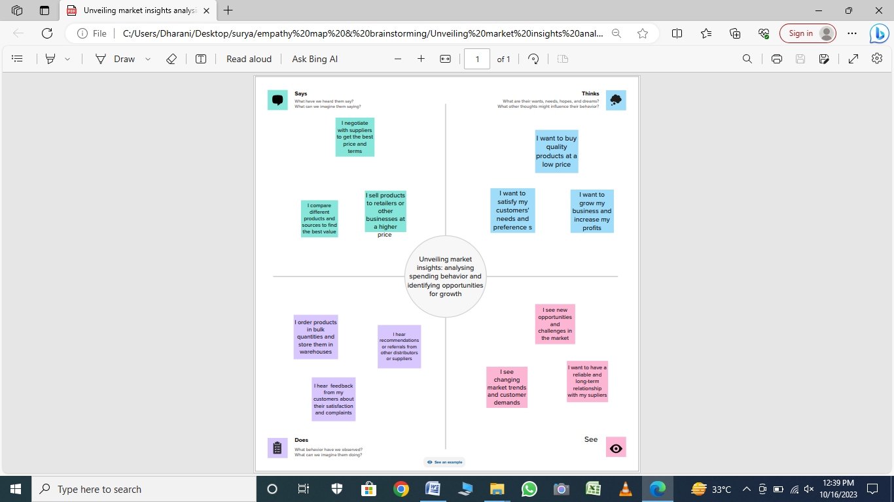

BRAINSTORMING MAPS :

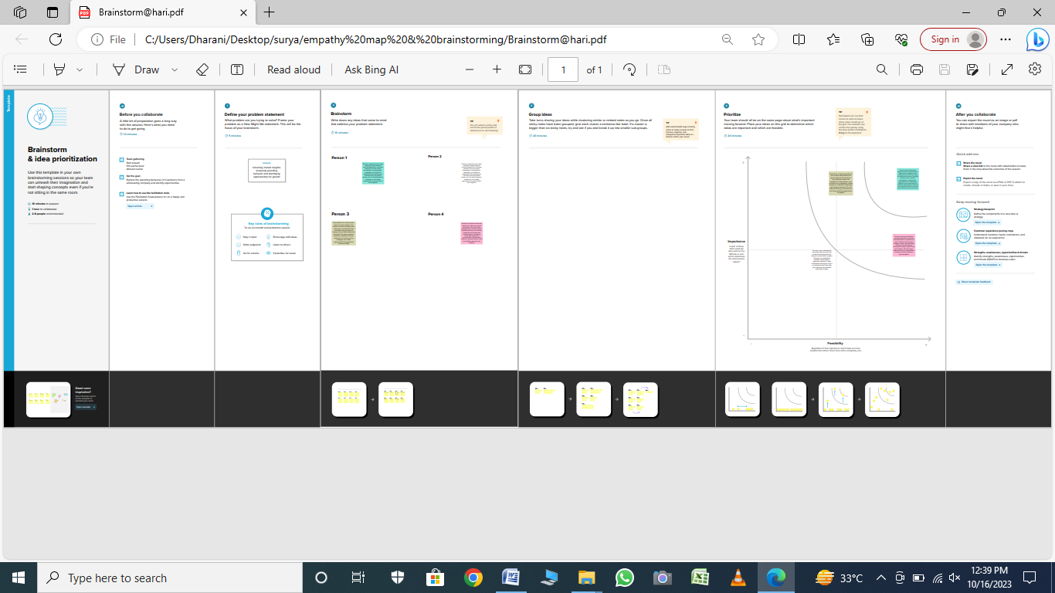

ADVANTAGES :

1. **Achieving Strategic Objectives**: Many projects are initiated to help organizations achieve their strategic goals and objectives. Successful projects contribute to the overall mission of the organization.
2. **Increased Efficiency**: Projects often aim to improve processes, streamline operations, and enhance efficiency within an organization, leading to cost savings and resource optimization.
3. **Innovation and Growth**: Projects can be catalysts for innovation, helping organizations develop new products, services, or processes that promote growth and competitiveness.
4. **Market Expansion**: Entering new markets, reaching new customer segments, or expanding geographic reach are common advantages for many business-related projects.
5. **Revenue Growth**: Projects can lead to increased sales, revenue, and profitability. For example, a marketing campaign may result in higher sales, while a cost optimization project may increase profit margins.

DISADVANTAGES :

1. **Cost Overruns**: Projects can exceed their budget, leading to financial strain and resource allocation challenges.
2. **Time Delays**: Delays in project completion can impact scheduling, lead to missed opportunities, and increase costs.
3. **Scope Creep**: Uncontrolled changes or additions to the project scope can lead to inefficiencies, increased costs, and project delays.
4. **Resource Constraints**: Inadequate resources, such as skilled personnel, technology, or equipment, can hinder project progress and quality.
5. **Quality Issues**: Rushed or inadequate project execution can result in quality problems, affecting the project's long-term success.

APPLICATION :

1. **Construction and Engineering**:
   * Building construction projects: The construction of residential, commercial, and infrastructure projects.
   * Infrastructure development: Projects to build or upgrade roads, bridges, airports, and public transport systems.
   * Civil engineering projects: Construction of dams, tunnels, and other major infrastructure facilities.
2. **Information Technology**:
   * Software development projects: Creating new software applications, systems, or websites.
   * IT infrastructure projects: Building or upgrading data centers, networks, and server systems.
   * Cybersecurity projects: Implementing measures to enhance digital security and protect against cyber threats.
3. **Manufacturing**:
   * Product development projects: Developing and launching new products or improving existing ones.
   * Process improvement projects: Enhancing manufacturing processes for increased efficiency and quality.
4. **Healthcare**:
   * Hospital construction and expansion projects: Building or upgrading medical facilities.
   * Healthcare IT projects: Implementing electronic health records (EHR) systems and telemedicine platforms.
   * Clinical trials and research projects: Investigating new treatments and drugs.
5. **Marketing and Advertising**:
   * Marketing campaigns: Planning and executing advertising and promotional activities.
   * Branding projects: Developing and rebranding products or companies.
6. **Education**:
   * Curriculum development projects: Creating new educational programs or courses.
   * School construction projects: Building or renovating educational facilities.
7. **Nonprofits and Social Services**:
   * Community development projects: Initiatives to improve living conditions in disadvantaged areas.
   * Humanitarian relief projects: Providing aid in disaster-stricken regions.
8. **Government and Public Sector**:
   * Public infrastructure projects: Initiatives to improve public services, such as roads, bridges, and public transportation.
   * Policy development projects: Research and analysis to inform government policies.
9. **Energy and Environment**:
   * Renewable energy projects: Development of solar, wind, or hydropower facilities.
   * Environmental conservation projects: Initiatives to protect and preserve natural resources and ecosystems.
10. **Aerospace and Defense**:
    * Aerospace engineering projects: Designing and manufacturing aircraft, spacecraft, and defense systems.
    * Defense research and development projects: Developing advanced military technologies.
11. **Financial Services**:
    * Investment and portfolio management projects: Managing investment strategies and financial portfolios.
    * Risk management projects: Mitigating financial risks through modeling and analysis.
12. **Retail**:
    * Store openings and expansions: Expanding retail operations through new stores or market entry.
13. **Entertainment and Media**:
    * Film and TV production projects: Developing and producing movies and television shows.
    * Event management projects: Planning and executing live events and concerts.
14. **Research and Development**:
    * Scientific research projects: Conducting research in fields like biology, physics, and chemistry.
    * Innovation projects: Exploring and developing new technologies and ideas.
15. **Agriculture**:
    * Crop improvement projects: Enhancing crop yields and quality through breeding and genetic research.
    * Irrigation projects: Developing systems for efficient water use in agriculture.
16. **Real Estate**:
    * Real estate development projects: Construction of residential, commercial, and industrial properties.
17. **Transportation and Logistics**:
    * Transportation infrastructure projects: Expanding or improving transportation networks, such as airports and ports.
    * Supply chain optimization projects: Enhancing the efficiency of distribution and logistics.

Projects are essential tools for driving change and improvement across various industries and sectors. They enable organizations to address specific needs, create new opportunities, and respond to challenges, ultimately contributing to their growth and success.

Top of Form

CONCLUSION :

1. **Final Deliverables**: Ensure that all project deliverables have been successfully completed, meeting the defined quality standards and requirements.
2. **Documentation**: Thoroughly document all aspects of the project, including lessons learned, final reports, and any necessary project closure documents.
3. **Review and Evaluation**: Conduct a comprehensive review and evaluation of the project to assess its success and to identify areas where improvements could be made in future projects.
4. **Stakeholder Acceptance**: Obtain formal acceptance from stakeholders that the project has met their expectations and requirements.
5. **Transition and Handover**: If applicable, plan and execute the transition of project outputs or systems to the end-users or operational teams, ensuring a smooth handover process.

FUTURE SCOOPE :

1. **Scaling and Expansion**: Evaluate the potential to scale up the project's results. For example, if a pilot project is successful, it may be expanded to cover a larger geographic area or a broader customer base.
2. **Continuous Improvement**: Identify areas where the project can be further refined or improved. This might involve revisiting the project plan and using feedback to enhance processes or deliverables.
3. **New Initiatives**: Consider how the project's outputs can be used as a foundation for new initiatives or projects. Successful project outcomes can inspire the creation of related or complementary projects.
4. **Replication**: Assess whether the project's success can be replicated in different locations, industries, or contexts. This could lead to new opportunities for replication projects.
5. **Innovation and Research**: Explore how the knowledge and insights gained from the project can contribute to ongoing research and innovation efforts within the organization or industry.

RESULTS :

